PHYSICS – ORDINARY LEVEL SOLUTIONS 2021

2021 Question 1

- Draw a labelled diagram of the apparatus used in this experiment.
labelled diagram to show:
falling object e.g. (metal) ball
starting mechanism e.g. release mechanism
stopping mechanism e.g. trapdoor
means of measuring time e.g. timing circuit/ (electronic) timer
- How did the student measure the distance s?
metre stick / ruler / measuring tape
- How did the student measure the time t for the object to fall?
timer
- How did the student improve the accuracy of the time t that was used?
take the smallest time for t, repeat, took average, place a paper between the ball and magnet, use large distance/s, used a more accurate timer / electronic timer, etc.
- Use this data and the formula $g=\frac{2s}{t^{2}}$ to calculate a value for g.
$g=\frac{2s}{t^{2}}=\frac{2(0.4)}{{(0.29)}^{2}}=\frac{0.8}{0.0841}$ = 9.5 m s⁻²
- Use the results to calculate two other values for g and calculate their average.
9.76 m s⁻², 9.8 m s⁻², 9.69 m s⁻², 10 m s⁻², 9.73 m s⁻²
average of any two above
- The maximum distance used is 0.9 m. Why does the student not use a greater distance?
difficult to measure with metre stick, difficult to align the ball with the trapdoor, etc.

2021 Question 2

- of the apparatus used in this experiment.
labelled diagram to show:
enclosed volume of gas
means of measuring/reading the volume scale
means of measuring/ reading the pressure e.g. pressure gauge
means of altering the pressure/volume e.g. pump
- How is the pressure varied in this experiment?
pump / valve // piston // screw mechanism which can be turned
- Explain why.
to allow the gas to settle (to room temperature/ to cool)
- For each value of V in the table above, calculate $\frac{1}{V}$ to three decimal places.
V (cm³) | 19 | 17 | 15 | 13 | 11 | 9
$\frac{1}{V}$ (cm⁻³) | 0.053 | 0.059 | 0.067 | 0.077 | 0.091 | 0.111

- Plot a graph on graph paper of p against $\frac{1}{V}$.
label axes correctly, (name / symbol / unit)
plot six points correctly
straight line
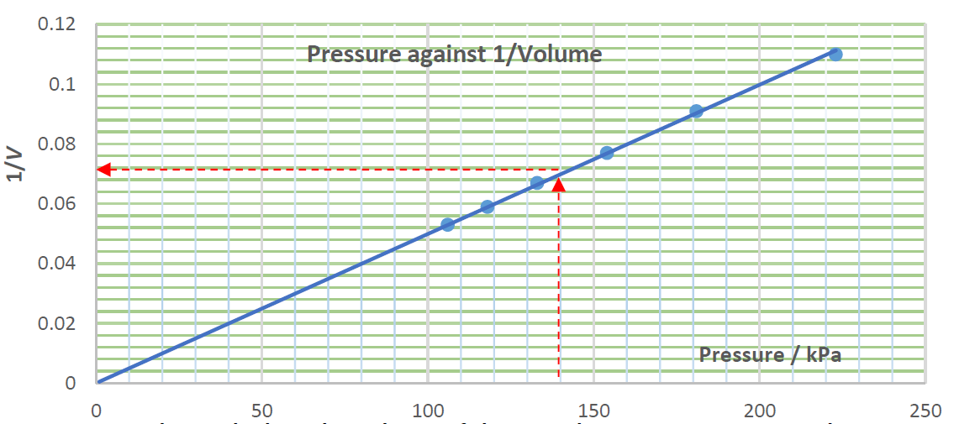
- Use your graph to calculate the volume of the gas when its pressure is 140 kPa.
Go to 140 kPa on pressure axis, then up to the line and over to the 1/V axis.
Read $\frac{1}{V}$ value from graph (e.g. 0.07) and invert this value to get V = 14.3 cm⁻³.

2021 Question 3

- Draw a labelled diagram of the apparatus used in this experiment.
object e.g. crosswire, raybox
(converging) lens
screen
correct arrangement, optical bench, metre stick, etc.
- On your diagram, indicate and label the object distance u and the image distance v.
correctly marked u and v distances
- Name the instrument used to measure the object distance and the image distance.
metre stick, measuring tape, optical bench with scale, ruler
- How did the student know that the correct image distance had been found?
image in sharp focus
- State the formula used to calculate f.
$$\frac{1}{f}=\frac{1}{u}+\frac{1}{v}$$
- Calculate the focal length of this lens.
$\frac{1}{f}=\frac{1}{16}+\frac{1}{48}$ $\frac{1}{f}=\frac{1}{12}$ f = 12 cm
- Why will this experiment not work if the object is placed very close to the lens?
virtual image (formed when u< f ), cannot form image on screen

2021 Question 4
A student carried out an experiment to measure l, the specific latent heat of vaporisation of water.
Steam at 100 °C was passed into cold water in a copper calorimeter.
The student recorded the following results.

Mass of empty calorimeter | = 0.0894 kg
Mass of calorimeter and cold water | = 0.1327 kg
Initial temperature of calorimeter and cold water | = 20 °C
Final temperature of calorimeter, water and added steam | = 36 °C
Final mass of calorimeter, water and added steam | = 0.1341 kg

- Draw a labelled diagram of the apparatus used in this experiment.
labelled diagram to show:
calorimeter with water
steam source
thermometer
insulation
steam trap
- Calculate the mass of the cold water (A).
(0.1327 – 0.0894) = 0.0433 kg
- Calculate the mass of the added steam (B).
(0.1341 – 0.1327) = 0.0014 kg
- Calculate the increase in temperature of the calorimeter and cold water (C).
(36 – 20) = 16 °C
- Calculate the decrease in temperature of the steam (D).
(100 – 36) = 64 °C
- Use your values for A, B, C and D to complete the following calculations to find l.

Heat lost by steam = Heat gained by water and calorimeter

m_{steam}l + m_{steam}c_{water}Δϴ_{steam} = m_{water}c_{water}Δϴ_{water} + m_{cal}.c_{copper}Δϴ_{cal}.

B × l + B × 4200 × D = A × 4200 × C + 0.0894 × 390 × C
(0.0014) l + (0.0014)(4200)(64) = (0.0433)(4200)(16) + (0.0894)(390)(16)

(0.0014) l = 3090 ⇒ l = 2.2 × 10⁶ J kg⁻¹

2021 Question 5
- Name the instrument used to measure voltage.
voltmeter
- Name the instrument used to measure current.
ammeter
- How did the student change the voltage across the conductor?
adjust variable voltage // adjust the variable resistor
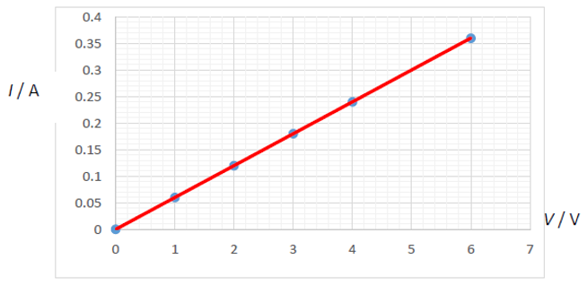
- Use the data to plot a graph on graph paper to show the relationship between I and V.
label axes correctly, (name / symbol / unit)
plot six points correctly
straight line

- Describe the relationship between current and voltage for this conductor.
V ∝ I // They are proportional
- What would you notice if the experiment was repeated using a filament bulb instead of a metallic conductor?
there would be a curve instead of a straight line

2021 Question 6
Answer any eight of the following parts (a), (b), (c), etc.

- Explain the underlined term.
no movement / no acceleration / nett force zero / balanced
- Calculate the distance it travels in 12 s.
$s=ut+\frac{1}{2}at^{2}=0+\frac{1}{2}\left(6\right)({12}^{2})$ = 432 m
- Water has a density of 997 kg m⁻³. Calculate the pressure due to water at a depth of 214 m.
(𝑃 = ℎ𝜌𝑔 = (214)(997)(9.8) =) 2.1 × 10⁶ Pa
- Name the secondary colour which mixes with red light to form white light.
turquoise / cyan
- What is the Doppler effect?
Apparent change in (wave) frequency /wavelength due to moving source/observer
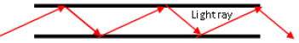
- Draw a diagram to show how light is transmitted along an optical fibre.
diagram showing fibre and multiple internal reflections

- What do the letters 𝐹, 𝑞, and 𝑑 stand for in this expression?
force, charge and distance between charges
- State the SI unit of (i) magnetic flux density, (ii) capacitance.
(i) tesla/T (ii) farad/F
- What property of tungsten makes it suitable for this use?
high melting point // high atomic number//high density
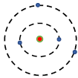
- Silicon is an example of a semiconductor. What is a semiconductor?
substance whose resistivity/conductivity is between that of a conductor and insulator
- Draw a diagram to outline the Bohr model of the atom.
diagram showing nucleus, electron shell, another electron shell
- What is the photoelectric effect?
emission of electrons (from a metal surface) by (incident) light

2021 Question 7

- What is meant by momentum?
mass multiplied by velocity
- State the principle of conservation of momentum.
(in a closed system the total) momentum before (interaction) = (the total)momentum after
- Explain why Newton’s second law of motion is consistent with the principle of conservation of momentum.
no force acting implies no change in momentum
- Calculate the momentum of Bagger 293 when it is moving at its maximum speed.
mv = (14200 × 103)(0.17) = 2.4 × 10⁶ kg m s⁻¹
- Would this cause its speed to increase or to decrease?
Mass after ‘collision’ has increased so the speed will decrease (for momentum to be conserved)

- Calculate the initial momentum of train X.
mv = (0.133)(0.05) = 6.65 × 10⁻³ kg m s⁻¹
- Calculate the speed of the two trains immediately after the collision.
Combined mass of two trains after = 179 g = 0.179 kg
total momentum before collision = total momentum after collision
(6.65 × 10⁻³) = (0.179)(v) ⇒ v = 0.037 m s⁻¹
- In which direction do the two trains move after the collision?
to the right // in the same direction as the moving train
- Calculate the loss in kinetic energy during this collision.
$KE before=\frac{1}{2}mv^{2}= \frac{1}{2}(0.133)({0.05}^{2})$ =1.66 × 10⁻⁴ J
$KE after=\frac{1}{2}mv^{2}= \frac{1}{2}(0.179)({0.037}^{2})$ =1.22 × 10⁻⁴ J
kinetic energy lost = 0.44 × 10⁻⁴ J

- What happened to the kinetic energy that was lost in the collision?
converted into heat // converted into other forms

2021 Question 8
- Describe an experiment to show that sound waves need a medium to travel through.
apparatus: bell jar with electric bell, battery, vacuum pump
procedure: turn on pump
observation/conclusion: no sound heard when air removed / sound needs a medium
- What type of waves do not need a medium to travel through?
light / electromagnetic
- Distinguish between transverse and longitudinal waves.
the disturbance is parallel to the direction of motion for longitudinal waves
the disturbance is perpendicular to the direction of motion for transverse waves
- Calculate the speed of the radio waves.
v = f 𝜆 = (107 × 10⁶ )(2.804) = 3 × 10⁸ m s⁻¹

- Describe one example of the reflection of sound waves.
When sound is reflected from a distant obstacle it produces an echo

- Calculate the refractive index of the glass.
$n=\frac{\sin{i}}{\sin{4}}=\frac{0.3907}{0.2588}$ = 1.51
- Copy and complete the diagram to show this wave undergoing diffraction.
See diagram
- Describe an experiment to show that sound undergoes interference.
method: e.g. slowly rotate vibrating tuning fork near the ear
observation/conclusion: e.g. change in loudness due to interference
- Explain with the aid of a labelled diagram what is meant by polarisation.
labelled diagram to show the restriction of (transverse) wave vibrations to a single plane

2021 Question 9
- Define resistance.
Resistance is defined as the ratio of the potential difference across a conductor to the current flowing through it.
$R=\frac{V}{I}$ with notation
- Name the instrument used to measure resistance.
ohmmeter

- State the relationship between resistance and length.
R ∝ l
- Calculate the circular cross‐sectional area of the wire.
$A=πr^{2}=π({0.2×{10}^{-3})}^{2}$ = 1.26 × 10⁻⁷ m²
- Calculate the resistance of the wire.
$R=\frac{ρL}{A}=\frac{(1.1×{10}^{-6})(4.8)}{1.2566×{10}^{-7}}$ = 42 Ω
- Show that the combined resistance of the three resistors in parallel is 1.05 Ω.
$\frac{1}{R}=\frac{1}{5}+\frac{1}{2}+\frac{1}{4}=\frac{19}{20}$ R = 1.05 Ω
- Calculate the total resistance in the circuit.
R_{Total} = 3 + 1.05 = 4.05 Ω
- Calculate the current flowing through the ammeter, A.
$I=\frac{V}{R}$ = $\frac{12}{4.05}$ = 2.96 A
- What is the function of this wire?
safety/ earth (the equipment)
- Name the wire labelled Q.
live

2021 Question 10
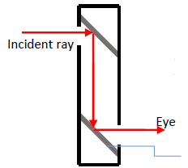
- Describe how a periscope works.
See diagram
- State the laws of reflection of light.
the incident ray, the normal and the reflected ray are in the same plane
the angle of incidence is equal to the angle of reflection
- Describe an experiment to demonstrate the laws of reflection.
apparatus: plane mirror, sheet of paper, raybox / pins, protractor any two
procedure: draw the incident ray, normal and reflected ray // measure i and r
observation / conclusion: the angle of incidence is always equal to the angle of reflection
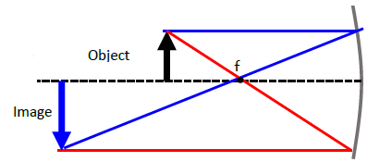
- Show how a real image is formed in a concave mirror.
See diagram

- Calculate the magnification.
$M= \frac{v}{u}=\frac{3}{2}$
- Calculate the image distance.
v = 1.5u = (1.5)(17) = 25.5 cm
- State one use of a concave mirror.
cosmetics, shaving mirror, dentist, etc
- State one use of a convex mirror.
car mirror, security mirror in shops, road reflectors, etc.

2021 Question 11

- Name the other way in which heat may be transferred.
convection
- Distinguish between heat and temperature.
heat is a measure of the energy in a body while temperature is a degree of hotness
- Convert the normal human body temperature from degrees Celcius (°C) into kelvin (K).
(37 °C = 37 + 273 = ) 310 K
- What is a thermometric property?
(measurable) property which changes with temperature change
- State one example of a thermometric property.
colour, voltage, volume, pressure, resistance, etc.
- Explain why this is the case.
different thermometric properties behave differently with changing temperature
- Calculate the area of the garden.
A=(6)(9) = 54 m²
- Calculate how many seconds there are in 12 hours.
(12)(60)(60)= 43200 s
- Calculate how much energy will fall on the garden in the 12 hours.
E = (1.36 × 10³)(43200)(54) = 3.17 × 10⁹ J
- Describe an experiment to compare the rate of conduction through different solids.
apparatus 3
method 3
observation/conclusion
- Describe two ways of reducing heat loss from a building.
Insulation and double glazing

2021 Question 12
- What is nuclear fission?
splitting up of a nucleus ( into two parts) with the emission of particles /energy

- What is the function of the control rods in a fission reactor?
absorb neutrons // slow down the rate of fission/reaction
- A fission reactor is surrounded by shielding. What is the purpose of the shielding?
protection / safety /prevent radiation escaping
- What material is used as shielding?
lead / concrete
- State one disadvantage of nuclear fission.
radioactive waste/ explosions/nuclear accidents
- How many electrons are in an atom of Mt?
${Mt}_{109}^{268}$ neutral atom so 109 protons means 109 electrons also
- What is meant by radioactivity?
(spontaneous) emission of (alpha and beta particles and gamma) rays from unstable nuclei
- Which type of nuclear radiation is the most penetrating?
gamma
- Describe an experiment to compare the penetrating power of the three types of nuclear radiation.
apparatus: radioactive sources, barriers, detector/GM tube
procedure: place different barriers between the sources and the detector
observation/conclusion: alpha is stopped first // gamma penetrates best
- What are isotopes?
atoms of the same element with different numbers of neutrons
- How many neutrons are in this isotope?
247 – 96 ) 151 neutrons

2021 Question 13
  - What did Millikan determine with his 1909 oil drop experiment?
size of the charge on an electron/there was a smallest unit charge
  - What is the size of the charge on one electron?
1.6 × 10⁻¹⁹ C
  - How are the electrons produced in an X‐ray tube?
thermionic emission // hot cathode
  - Calculate the mass of the drop.
Mass = ρV = (886)(2.03 × 10⁻¹⁷) = 1.8 × 10⁻¹⁴ kg
  - Draw the circuit symbol for a battery.
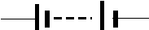
  - What is an electric field?
region/space around a charge in which another charged particle will experience a force
  - Sketch the electric field that is formed between two oppositely charged parallel plates.
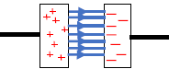
  - Show the forces acting on the drop when it is not moving up or down.
labelled diagram to show electric force acting up and gravity down

14. Answer any two of the following parts (a), (b), (c), (d).

2021 Question 14 (a)

- Calculate the rocket’s average speed during this part of the journey.
$v=\frac{s}{t}=\frac{6484×{10}^{3}}{(15)(60)}$ = 7.2 km s⁻¹
- How many full orbits of the Earth does the ISS complete each day?
number of orbits = $\frac{(24)(60)}{93}$ = 15.48 so 15 full orbits
- State Newton’s law of universal gravitation.
Force of attraction between two point masses is proportional to the product of the masses and inversely proportional to the square of the distance between them
- Calculate the astronaut’s weight on Earth.
weight = mg = (85)(9.8) = 833 N
- What is the astronaut’s mass at the altitude of the ISS?
(mass does not change) = 85 kg
- Calculate the astronaut’s weight at the altitude of the ISS.
(0.9)(833) = 749.7 N

2021 Question 14 (b)

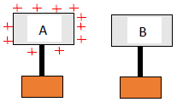
- Explain how objects can be charged by induction.
A charged object A is brought near to but not touching a neutral conducting object B.
Object B is then earthed.
Object A is then removed
- Calculate the power generated when lightning discharges.
$Power=\frac{work}{time}=\frac{0.9×{10}^{9}}{3×{10}^{-4}}$ = 3 × 10¹² W
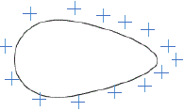
- Draw a diagram to show the distribution of charge on a pear shaped conductor.
See diagram
- Describe an experiment to show that static charge accumulates on the outside of a metal object.
apparatus: e.g. charged hollow conductor, proof plane, Gold leaf electroscope
Procedure: e.g. touch the proof plane against the inside of the charged conductor and then against the cap of the GLE.
Repeat touching the proof plane against the outside of the charged conductor.
observation/conclusion: the leaf of the GLE deflects/moves when the proof plane was touched against the outside of the conductor but not the inside.

2021 Question 14 (c)

- What is a magnetic field?
region/space around a magnet where magnetic forces act
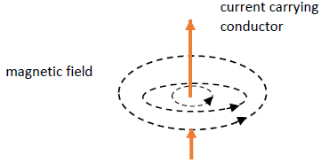
- Describe an experiment to plot the magnetic field around a bar magnet.
apparatus: magnet, plotting) compass / iron filings
procedure: use the apparatus to locate the field lines e.g. (place the compass on the paper and) mark the dots // sprinkle filings
observation/conclusion: join the dots/ show field lines / lines go from north to south/ field lines are concentrated at the magnet poles // tap filings
- Draw a diagram to show the magnetic field around a current‐carrying conductor.
Se diagram
- How could a student show that a current‐carrying conductor experiences a force in a magnetic field?
apparatus: current carrying conductor e.g. 6V battery, tin foil, magnet, leads 2
procedure: (briefly) connect the circuit 2
observation/conclusion: e.g. tin foil moves when magnet is near
- State one use of magnets.
specific use e.g. in compass for direction, to seal fridge door, etc

2021 Question 14 (d)
- What is the unit of sound intensity level?
bel / B / decibel / dB
- Describe an experiment to demonstrate resonance.
apparatus: two objects with the same natural frequency e.g. two mounted tuning forks (of the same frequency) 3
procedure: e.g. set one vibrating and bring the other close 3
observation/conclusion: energy transfer e.g. the second tuning fork vibrates
- State this relationship.
frequency is inversely proportional to the length
- Calculate the wavelength of the wave.
𝜆 = 2(0.4) = 0.8 m
- Calculate the frequency of the wave.
v = f𝜆 $f=\frac{v}{λ}=\frac{380}{0.8}$ = 475 Hz

